Evaluation: Provincial Stroke Rounds – November 3rd 2021

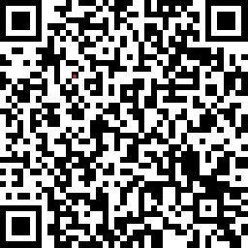
Topic: Advance Care Planning in Stroke
Presenter: Dr. Kelvin Ng, Gillian Maguire, NP, Leigh Barr, S-LP

Online Evaluation Link: https://www.surveymonkey.com/r/G52SRK2 QR Code:

Stated Presenter Objectives - Upon Completion the participants will be able to:
1. Understand stroke as a serious illness
2. Discuss stroke and critical treatment decisions
3. Understand Advance care planning in stroke
4. Describe special considerations for stroke patients and palliative care including MAID and stroke

- Please indicate your discipline:
☐ MD | ☐ OT | ☐ Recreation Therapist
☐ Medical Resident | ☐ PT | ☐ SLP
☐ Physician Assistant | ☐ OTA/PTA | ☐ Administrator
☐ NP | ☐ Social Work | ☐ Educator
☐ RN | ☐ Pharmacist | ☐ EMS
☐ RPN | ☐ Registered Dietitian | ☐ District Stroke Coordinator
 |  | ☐ Other

- This session enhanced my knowledge of:

Stroke Best Practice Recommendations ☐ Yes ☐ No
Knowledge of Current Research ☐ Yes ☐ No

- The presenters(s):

 | Strongly Disagree | Disagree | Neutral | Agree | Strongly Agree
Delivered their material clearly & effectively
Were effective in facilitating discussion
Provided adequate opportunities for interaction

- Did the presenter(s) meet their stated learning objectives? ☐ Yes ☐ No

- How will you apply knowledge gained from this session? List one or two things you will do differently.
- Was there an opportunity to be self-reflective? ☐ Yes ☐ No

- Did you perceive any degree of bias in the session? ☐ Yes ☐ No

IF bias perceived, please describe:

- Were you satisfied with use of technology? ☐ Yes ☐ No

- Suggestions for future stroke-related topics and speakers/Additional Comments

